# ABOUT THE ORGANIZATION

## 1.1 INTRODUCTION

The **Assam State Electricity Board** (ASEB) is an electricity regulation board of the state of [Assam](https://en.wikipedia.org/wiki/Assam) in [India](https://en.wikipedia.org/wiki/India). It is a Public Sector Undertaking managing the generation, transmission and distribution of electricity in the state of Assam with its successor companies [Assam Power Generation Co. Ltd.,](http://www.apgcl.org/) Assam Electricity Grid Corporation Ltd. and Assam Power Distribution Company Ltd.

Assam State Electricity Board was established in 1958 in the composite state of Assam under the Electricity Act 1948. The existing Board was reconstituted in 1975 after the state was trifurcated into Assam, Meghalaya and Mizoram in 1972. Two central government corporations, North Eastern Electric Power Corporation (NEEPCO) and the Power Grid Corporation of India Ltd(PGCIL) supplement the efforts of the state in power development in generation and transmission respectively.

## 1.2 APDCL

The Company, Assam Power Distribution Company Ltd(APDCL) was incorporated on the 23rd day of October, 2009 as a public limited company wholly owned by the Government of Assam. The ultimate object of the Company is to undertake the electricity distribution, trading, supply in the state of Assam or outside in accordance with provisions of Applicable Law and all activities ancillary or appurtenant thereto.

The main purpose of forming the Company was to take over, manage and operate the electricity distribution system, assets, liabilities, undertaking of the Assam State Electricity Board (ASEB), as may be transferred to it pursuant to a notified transfer scheme in terms of Part XIII of the Electricity Act, 2003. Subsequently, the Government of Assam notified the provisional transfer scheme vide Gazette notification bearing no. PEL. 151/2003/Pt./165 dated 10th December, 2004 as well as the final transfer scheme vide Gazette Notification PEL.151/2003/Pt./349 dated Dispur, the 16th August, 2005 under the Electricity Act, 2003 transferring the various assets, liabilities etc. of the ASEB to the Company.

The main object of the company is to develop, maintain and operate power distribution system in the state of Assam.

## 1.3 Vision of APDCL

"To be the catalyst for Holistic Growth of the State of Assam by powering Agriculture and Industry; lighting homes - rural and urban & generating internal resources for continually improving Technology & Delivery System to induce Customer Delight"

## 1.4 Mission of APDCL

Our Commitment is to make Assam Power Distribution Company (APDCL) the pride of ASSAM. According to the employees of APDCL, the following 15 KEY TASK AREAS should be undertaken to achieve Our Mission:

* Advanced planning for procurement of electricity to cater to the consumers according to demand.
* Enhancing the capacity of the electrical sub-divisions and distribution networks by investing in infrastructure.
* Expanding the distribution network to supply power to all the villages.
* Increasing awareness among the consumers about economic use of electricity.
* Replacement of Electro-Mechanical Meters with Electronic Meters.
* To give emphasis on 100% Revenue collection, energy audit and error-free billing.
* Engagement of Franchisee to improve the services to the consumers.
* To set up Vigilance Cell to detect unauthorized use of electricity.
* Training the employees for consumer-friendly behavior.
* To set up state-of-the-art customer care centre and carry out consumer indexing.
* Strong resolve for financial discipline.
* Take proper steps to increase faith among consumers.
* Proper planning for an effective HT/LT Ratio.
* To reduce AT&C Losses by augmenting 1-Ph lines wherever required and
* Installation of underground cable in lieu of overhead lines.

## 1.5 Contact Details of Jorhat APDCL Office

Bidyut Bhawan, Na Ali, Jorhat

P.O: Jorhat P.S:Jorhat

PIN: 785001

Phone: 0376-2320184 (O)

Mobile Number: 8638078852

Email: [dgmjec_apdcl@rediffmail.com](mailto:dgmjec_apdcl@rediffmail.com)

Website: www.apdcl.org

# 2. PROJECT OVERVIEW

## 2.1 PROJECT TITLE

The project is entitled as **“MATERIALS STOCK MANAGEMENT SYSTEM FOR JORHAT ELECTRICAL CIRCLE OF APDCL”.**

## 2.2 WHAT IS IT?

**MATERIALS STOCK MANAGEMENT SYSTEM** is an online application designed and implemented for the JORHAT ELECTRICAL CIRCLE OF APDCL. It is fully integrated web-based software solutions provide a easy way to store and requisitioned various materials for different divisions and sub-divisions of the **Jorhat Electrical Circle**.

## 2.3 NEED FOR THE SYSTEM

It is crucial for an organization today to understand its stock/inventory to achieve both efficient and fast operations, that too, at an affordable cost. An effective management of stock/inventory helps in reducing costs which further keeps accounts and finances in check. In simple terms, Stock Management System is a set of all those processes which utilize to oversee and organize goods or materials in storage/warehouse. Stock management supervises the flow of goods from manufacturers to storages/warehouses.

## 2.4 PROPOSED SYSTEM

The proposed system is mainly developed to provide easy way to store and requisition material for different departments. The system also keep record of repairing for different material specially transformer and load shading for different departments.

Some of the benefits and advantage of the proposed system are:

* Keeps tracks of inventory and offers a centralized view of stock.
* Control costs by making stock report for analysis of inventory.
* Manages planning and forecasting by analyzing data trends.
* Reduces the time for managing inventory by keeping records in place.
* The new proposed system calculates all the expenditures automatically and it is very fast and accurate.
* The proposed system is very fast with 100% accuracy and saves time.
* The proposed system needs less manpower. Less people can do the large work.
* The proposed system completes the work in less time.
* The most important benefit of this system is that it reduces the redundancy of data within the data.

## 2.4.1 ANALYSIS OF THE EXISTING SYSTEM

Stock Management System is associated with a constant flow of incoming and outgoing stock. But the manual handling of the record is time consuming and highly prone to error. The drawbacks of the manually handled system are listed below:

* The current manual system has a lot of paper work.
* It is a Time-consuming job to maintain all the records.
* With the increase in database, it will become a massive job to maintain the database.
* Requires large quantities of file cabinets, which are huge and require quite a bit of space in the office, which can be used for storing records of previous details.
* The retrieval of records of issued and repaired materials will be a tedious job.
* Lack of security for the records, anyone can disarrange the records the system.

From the above discussion it is clear that a new system is required to overcome these drawbacks. To establish the need of the new system, the following points are proposed:

* **Problem of Reliability**: Current system is not reliable. It seems to vary in quality from one month to the, next. Sometimes it gives good output, but sometimes the output is worst.
* **Problem of Accuracy**: There are too many mistakes in reports.
* **Problem of timeliness**: In the current system the reports and output produced is mostly late and in most of the cases it is useless because it is not on time.
* **Problem of Validity**: The output and reports mostly contains misleading information. The customer's information is sometimes not valid.
* **Problem of Economy**: The current system is very costly. We have to spend lots of money to keep the system up and going, but still not get the desired results.
* **Problem of Capacity**: The current system is suffering from problem of capacity also. The staff for organization is very less and the workload is too much. Few peoples cannot handle all the work.

## 2.4.2 OBJECTIVES OF PROPOSED SYSTEM

This project is aimed at developing an online materials stock management system for Jorhat Electrical Circle of APDCL. The system is an online application that can be accessed throughout the organization with proper login provided.

The proposed system maintains five levels of users:

1. Sub-Division
2. Division
3. Circle
4. Central Storage
5. CGM

**Sub-Division:**

Sub-division performs the following task-

* Maintain its own stock.
* Request made to division for requisition of material.
* Request made to division for repairing of transformers.
* It can view its requested requisitioned material and accepted the issued materials.

**Division:**

Division performs the following task-

* Maintain its own stock of material.
* If material is not available in its stock then requisition is forward to Circle otherwise issued it.
* It can view its requested requisitioned material and accepted the issued materials.

**Circle:**

Circle performs the following task-

* Add ,View & Update Departments.
* Add & View Purchase Record.
* Add user account for Division & Sub-Division for login.
* Entry new material to the material master.
* Maintain its own stock of material.
* Approve the requisition of material from division.
* If material is not available in its stock then requisition is forward to CGM otherwise issued it.
* It can view its requested requisitioned material and accepted the issued materials.

**Central Storage:**

Central Storage performs the following task-

* Maintain its own stock.
* Add different scheme for materials.
* Add & View Vendors.
* Add & View Materials Supply Records.
* If material is not available in its stock then requisition is forward to CGM otherwise issued it.

**CGM:**

CGM performs the following task-

* Maintain its own stock.
* Add different scheme for materials.
* Add & View Vendors.
* Add & View Materials Supply Records.
* Issue requested materials that forward from Central Store.

### 2.4.3 SCOPE OF THE PROPOSED SYSTEM

The following steps that give the detailed information regarding the scope of proposed system are:

* **Performance**: The proposed system is fully computerized and user friendly so that any member of the APDCL can easily use the system.
* **Efficiency**: The basic need of the project is efficiency. The project should be efficient so that whenever a material is requested for a requisition and automatically a status is assigned as **Pending**. When material issued to concerned department then the status change into **Issued**.
* **Control**: The complete control of the project is under the hands of authorized person who has the password to access this project and illegal access is not supposed to deal with.
* **Security**: Security is the main criteria for the proposed system. Since illegal access may corrupt the database and it will affect the Stock Management System. So security has to be given in this project.

# 3. FEASIBILITY STUDY

After initial investigation, feasibility study is carried out to check the workability of candidate system. Its impacts on the organizational ability to meet user needs and effective use of the system. Feasibility study is the testing of the proposed system according to its workability. The object of the feasibility system is not to solve the problem but to acquire a sense of its scope. During the study of the problem definition is centralized and aspects of the problem to be included in the system are determined. Consequently costs and benefits are estimated with the greater accuracy at this stage. The result of the feasibility study is a normal proposal. This is simply a report a formal document detailing the nature and scope of the proposed solution. The proposal summarizes what is known and what is going to be done.

There are three key considerations involved in the feasibility analysis. They are:

1. Technical feasibility.

2. Economic feasibility.

3. Operational feasibility.

### 3.1.1 TECHNICAL FEASIBILITY

During technical feasibility, the analyst evaluates the technical merits of the system, at the same time collecting additional information about the performance, reliability, maintain ability and product ability in some cases, this system analysis step also includes limited amount of the research and design.

We can summaries the technical feasibility of the proposed system in following points:-

* The proposed system is capable of holding data to be used.
* The proposed system being modular, if the developer wants can add more features in the future and as well as being able to expand the system.
* As far as the hardware and the software are concerned, the proposed system is completely reliable.

### 3.1.2 ECONOMIC FEASIBILITY

In economic feasibility, which is also known as cost-benefit analysis, benefits expected from candidate system are composed with the cost. If the benefits outweigh costs, then decision is made to design and implement the system. Otherwise, further justification or alteration in the proposed system will have to be made.

This project was developed using all open source software like PHP, MySQL database tool etc. No costs regarding purchase of software or license were required.

The proposed system is economically feasible because of the following reasons:-

* This system is one time investment system, where all the features required will be added.
* Since the project was developed using open source tools, therefore the cost of the proposed system will be much less.

### 3.1.3 OPERATIONAL FEASIBILITY

In general, people resistant to change and computers have been known to facilitate change. A survey should be made of how strong a reaction the user staff is likely to have towards the development of the computerized system.

This project provides user friendly interactions for getting relevant results.

## 3.2 CONCLUSION

From the observation made in the feasibility study described above, it can be concluded that the proposed system is feasible in all aspects and justified that the feasible study could be followed by the system analysis and system design phase. The proposed system is also capable of holding the data to be used and is capable of providing adequate response. Thus, the proposed system is technically, economically and operationally feasible.

# 4. TECHNOLOGY USED

## 4.1 SOFTWARE SPECIFICATIONS

The proposed system is comprised of the following software tools. These tools were chosen in such a manner taking into account the need for future enhancements, system longevity and maintainability.

* Operating System: Windows 10
* Languages/Scripts: PHP, HTML, Java Scripts, AJAX, JQuery.
* Application server: Apache 2.4.3 (XAMPP 7.2.4)
* IDE used: Sublime Text
* GUI Design: w3.css, Cascading Style Sheets (CSS) 3.0
* Browsers: Mozilla Firefox, Google Chrome
* Database: MySQL 5.5.20

### 4.1.1 PHP:

**PHP** is a server-side scripting language designed for web development but also used as a general-purpose programming language. PHP is now installed on more than 244 million websites and 2.1 million web servers. Originally created by RasmusLardurf in 1995, the reference implementation of PHP is now produced by The PHP Group. While PHP originally stood for Personal Home Page, it now stands for PHP: Hypertext Preprocessor, a recursive acronym.

**PHP** code is interpreted by a web server with a PHP processor module which generates the resulting web page: PHP commands can be embedded directly into an HTML source document rather than calling an external file to process data. It has also evolved to include a command-line interface capability and can be used in standalone graphical applications.

**PHP** is free software released under the PHP license, which is incompatible with the GNU General Public License (GPL) due to restrictions on the usage of the term PHP. PHP can be deployed on most web servers and also as a standalone shell on almost every operating system and platform, free of charge.

**PHP** is an HTML-embedded scripting language. Much of its syntax is borrowed from C, Java and Perl with a couple of unique PHP-specific features thrown in. The goal of the language is to allow web developers to write dynamically generated pages quickly.

**PHP Syntax**

The following “Hello User” program is written in PHP code embedded in an HTML document:  
<! DOCTYPE html>  
<html>  
<head>  
<title>PHP Test</title>  
</head>  
<body>  
<? php echo '<p>Hello </p>';?>  
</body>  
</html>

The PHP interpreter only executes PHP code within its delimiters. Anything outside  
its delimiters is not processed by PHP (although non-PHP text is still subject to control  
structures described in PHP code). The most common delimiters are <? php to open and ?>  
to close PHP sections. There are also the shortened forms <? or <?= (which is used to echo  
back a string or variable) and ?>. Short delimiters make script files less portable, since  
support for them can be disabled in the local PHP configuration, and they are therefore  
discouraged. The purpose of all these delimiters is to separate PHP code from non-PHP  
code, including HTML.

In terms of keywords and language syntax, PHP is similar to most high level  
languages that follow the C style syntax. *if* conditions, *for* and *while* loops, and function  
returns are similar in syntax to languages such as C, C++, C#, Java and Perl.

### 4.1.2 XAMPP:

**XAMPP** is a [free and open-source](https://en.wikipedia.org/wiki/Free_and_open-source) [cross-platform](https://en.wikipedia.org/wiki/Cross-platform) [web server](https://en.wikipedia.org/wiki/Web_server) [solution stack](https://en.wikipedia.org/wiki/Solution_stack) package developed by Apache Friends, consisting mainly of the [Apache HTTP Server](https://en.wikipedia.org/wiki/Apache_HTTP_Server), [MariaDB](https://en.wikipedia.org/wiki/MariaDB) [database](https://en.wikipedia.org/wiki/Database), and [interpreters](https://en.wikipedia.org/wiki/Interpreter_(computing)) for scripts written in the PHP and Perl [programming languages](https://en.wikipedia.org/wiki/Programming_language). Since most actual web server deployments use the same components as XAMPP, it makes transitioning from a local test server to a live server possible.

The term XAMPP is an apparent [acronym](https://en.wikipedia.org/wiki/Acronym_and_initialism). However, there is no official acronym expansion specified on the Apache Friends website. Their homepage header reads "XAMPP Apache + MariaDB + PHP + Perl", indicating that this [abbreviation](https://en.wikipedia.org/wiki/Abbreviation) is a [recursive acronym](https://en.wikipedia.org/wiki/Recursive_acronym).

The term can be unofficially broken down as follows:

|  |  |
| --- | --- |
| Letter | Meaning |
| X | as an [ideographic](https://en.wikipedia.org/wiki/Ideogram) letter referring to [cross-platform](https://en.wikipedia.org/wiki/Cross-platform). |
| A | [Apache](https://en.wikipedia.org/wiki/Apache_HTTP_Server)or its expanded form, Apache HTTP Server |
| M | [MariaDB](https://en.wikipedia.org/wiki/MariaDB) (formerly: [MySQL](https://en.wikipedia.org/wiki/MySQL)) |
| P | PHP |
| P | PERL |

Officially, XAMPP's designers intended it for use only as a development tool, to allow website designers and programmers to test their work on their own computers without any access to the Internet. To make this as easy as possible, many important security features are disabled by default. XAMPP has the ability to serve web pages on the [World Wide Web](https://en.wikipedia.org/wiki/World_Wide_Web).A special tool is provided to [password-protect](https://en.wikipedia.org/wiki/Password) the most important parts of the package.

XAMPP also provides support for creating and manipulating databases in [MariaDB](https://en.wikipedia.org/wiki/MariaDB) and [SQLite](https://en.wikipedia.org/wiki/SQLite) among others.

### 4.1.3 SUBLIME TEXT:

Sublime Text is a [proprietary](https://en.wikipedia.org/wiki/Proprietary_software) [cross-platform](https://en.wikipedia.org/wiki/Cross-platform) [source code editor](https://en.wikipedia.org/wiki/Source_code_editor) with a [Python](https://en.wikipedia.org/wiki/Python_(programming_language)) [application programming interface](https://en.wikipedia.org/wiki/Application_programming_interface) (API). It natively supports many [programming languages](https://en.wikipedia.org/wiki/Programming_languages) and [markup languages](https://en.wikipedia.org/wiki/Markup_languages), and functions can be added by users with [plugins](https://en.wikipedia.org/wiki/Plugins), typically community-built and maintained under [free-software licenses](https://en.wikipedia.org/wiki/Free_software_licenses).

The following is a list of features of Sublime Text:

* "Goto Anything," quick navigation to files, symbols, or lines
* "Command palette" uses adaptive matching for quick keyboard invocation of arbitrary commands
* [Simultaneous editing](https://en.wikipedia.org/wiki/Simultaneous_editing): simultaneously make the same interactive changes to multiple selected areas
* Python-based plugin API
* Project-specific preferences
* Extensive customizability via JSON settings files, including project-specific and platform-specific settings
* Cross-platform (Windows, [macOS](https://en.wikipedia.org/wiki/MacOS), and Linux) and Supportive Plugins for cross-platform
* Compatible with many language grammars from [TextMate](https://en.wikipedia.org/wiki/TextMate)

### 4.1.4 .1 W3.CSS:

W3.CSS is a Cascading Style Sheet (CSS) developed by [w3schools.com](https://www.w3schools.com/). It helps in creating faster, beautiful, and responsive websites. It is inspired from Google Material Design.

Some of its salient features are as follows −

* In-built responsive designing
* Standard CSS
* Inspired by Google Material Design
* Free to use

**One Can Use w3.css to:**

1. W3.CSS has in-built responsive designing so that the website created using W3.CSS will redesign itself as per the device size.
2. W3.CSS has a 12 column mobile-first fluid grid that supports responsive classes for small, large, and medium screen sizes.
3. W3.CSS classes are created in such a way that the website can fit any screen size.
4. The websites created using W3.CSS are fully compatible with PC, tablets, and mobile devices.

### 4.1.4.2 HTML:

**Hyper Text Markup Language**, commonly referred to as **HTML**, is the standard markup language used to create web pages. It is written in the form of HTML elements consisting of tags enclosed in angle brackets (like <html>). HTML tags most commonly come in pairs like<h1> and </h1>, although some represent empty elements and so are unpaired, for example <img>. The first tag in such a pair is the start tag, and the second is the end tag (they are also called opening tags and closing tags).

Web browsers can read HTML files and render them into visible or audible web pages. Browsers do not display the HTML tags and scripts, but use them to interpret the content of the page. HTML describes the structure of a website semantically along with cues for presentation, making it a markup language, rather than a programming language.

HTML elements form the building blocks of all websites. HTML allows images and objects to be embedded and can be used to create interactive forms. It provides a means to create structured documents by denoting structural semantics for text such as headings, paragraphs, lists, links, quotes and other items. It can embed scripts written in languages such as JavaScript which affect the behavior of HTML web pages.

### 4.1.4.3 AJAX:

AJAX stands for Asynchronous JavaScript and XML. AJAX is a new technique for creating better, faster, and more interactive web applications with the help of XML, HTML, CSS, and Java Script. Ajax uses XHTML for content, CSS for presentation, along with Document Object Model and JavaScript for dynamic content display. AJAX is a web browser technology independent of web server software. A user can continue to use the application while the client program requests information from the server in the background.

Conventional web applications transmit information to and from the sever using synchronous requests. It means we have to fill out a form, hit submit, and get directed to a new page with new information from the server. With AJAX, when we hit submit, JavaScript will make a request to the server, interpret the results, and update the current screen. In the purest sense, the user would never know that anything was even transmitted to the server.XML is commonly used as the format for receiving server data, although any format, including plain text, can be used.

**Steps of AJAX Operation**

* A client event occurs.
* An XMLHttpRequest object is created.
* The XMLHttpRequest object is configured.
* The XMLHttpRequest object makes an asynchronous request to the Webserver.
* The Webserver returns the result containing XML document.
* The XMLHttpRequest object calls the callback () function and processes the result.
* The HTML DOM is updated.

### 4.1.4.4jQuery:

jQuery is a fast and concise JavaScript Library created by John Resig in 2006 with a nice motto − **Write less, do more**. jQuery is a JavaScript toolkit designed to simplify various tasks by writing less code. jQuery simplifies HTML document traversing, event handling, animating, and Ajax interactions for rapid web development.The important core features supported by jQuery are−

* **DOM manipulation −**The jQuery made it easy to select DOM elements, traverse them and modifying their content by using cross-browser open source selector engine called **Sizzle**.
* **Event handling −** The jQuery offers an elegant way to capture a wide variety of events, such as a user clicking on a link, without the need to clutter the HTML code itself with event handlers.
* **AJAX Support −** The jQuery helps you a lot to develop a responsive and feature-rich site using AJAX technology.
* **Animations −** The jQuery comes with plenty of built-in animation effects which we can use in our websites.
* **Lightweight −** The jQuery is very lightweight library - about 19KB in size.
* **Cross Browser Support −** The jQuery has cross-browser support, and works well in IE 6.0+, FF 2.0+, Safari 3.0+, Chrome and Opera 9.0+

### 4.1.4.5 JAVASCRIPT:

JavaScript is what is called a Client-side Scripting Language. That means that it is a computer programming language that runs inside an Internet browser (a browser is also known as a Web client because it connects to a Web server to download pages). The way JavaScript works is interesting. Inside a normal Web page one can place some JavaScript code. When the browser loads the page, the browser has a built-in interpreter that reads the JavaScript code it finds in the page and runs it.

Web page designers use JavaScript in many different ways. One of the most common is to do field validation in a form. Many Web sites gather information from users in online forms, and JavaScript can help validate entries.

JavaScript is also used in environments that aren't web-based, such as PDF documents, sitespecific browsers, and desktop widgets. Newer and faster JavaScript virtual machines (VMs) and platforms built upon them have also increased the popularity of JavaScript for server-side web applications. On the client side, JavaScript has been traditionally implemented as an interpreted language, but more recent browsers perform just-in-time compilation.

### 4.1.4.6 CSS:

**Cascading Style Sheets (CSS)** is a style sheet language used for describing the look and formatting of a document written in a markup language. While most often used to change the style of web pages and user interfaces written in HTML and XHTML, the language can be applied to any kind of XML document, including plain XML, SVG and XUL. Along with HTML and JavaScript, CSS is a cornerstone technology used by most websites to create visually engaging Webpages, user interfaces for web applications, and user interfaces for many mobile applications.

CSS is designed primarily to enable the separation of document content from document presentation, including elements such as the layout, colors, and fonts. This separation can improve content accessibility, provide more flexibility and control in the specification of presentation characteristics, enable multiple HTML pages to share formatting by specifying the relevant CSS in a separate .css file, and reduce complexity and repetition in the structural content, such as semantically insignificant tables that were widely used to format pages before consistent CSS rendering was available in all major browsers. CSS makes it possible to separate presentation instructions from the HTML content in a separate file or style section of the HTML file. For each matching HTML element, it provides a list of formatting instructions. For example, a CSS rule might specify that "all heading 1 elements should be bold," leaving pure semantic HTML markup that asserts "this text is a level 1 heading" without formatting code such as a <bold> tag indicating how such text should be displayed.

This separation of formatting and content makes it possible to present the same markup page in different styles for different rendering methods, such as on-screen, in print, by voice (when read out by a speech-based browser or screen reader) and on Brailee-based, tactile devices. It can also be used to display the web page differently depending on the screen size or device on which it is being viewed. While the author of a web page typically links to a CSS file within the markup file, readers can specify a different style sheet, such as a CSS file stored on their own computer, to override the one the author has specified. If the author or the reader did not link the document to a style sheet, the default style of the browser will be applied. Another advantage of CSS is that aesthetic changes to the graphic design of a document (or hundreds of documents) can be applied quickly and easily, by editing a few lines in one file, rather than by a laborious (and thus expensive) process of crawling over every document line by line, changing markup.

## 4.1.5 MYSQL DATABASE

**What is a Database?**

A database is a separate application that stores a collection of data. Each database has one or more distinct APIs for creating, accessing, managing, searching and replicating the data it holds.

Other kinds of data stores can be used, such as files on the file system or large hash tables in memory but data fetching and writing would not be so fast and easy with those types of systems.

So now a day, we use relational database management systems (RDBMS) to store and manage huge volume of data. This is called relational database because all the data is stored into different tables and relations are established using primary keys or other keys known as foreign keys.

A **Relational Database Management System (RDBMS)**isasoftwarethat:

* Enables us to implement a database with tables, columns and indexes.
* Guarantees the Referential Integrity between rows of various tables.
* Updates the indexes automatically.
* Interprets an SQL query and combines information from various
* Tables.

**RDBMS Terminology:**

Before we proceed to explain MySQL database system, let's revise few definitions related to database.

* Database: A database is a collection of tables, with related data.
* Table: A table is a matrix with data. A table in a database looks like a simple spreadsheet.
* Column: One column (data element) contains data of one and the same kind, for example the column pageid.
* Row: A row (= tuple, entry or record) is a group of related data, for example the data of one page.
* Redundancy: Storing data twice, redundantly to make the systemfaster.
* Primary Key: A primary key is unique. A key value cannot occur twice in one table. With a key, you can find at most one row.
* Foreign Key: A foreign key is the linking pin between two tables.
* Compound Key: A compound key (composite key) is a key that consists of multiple columns, because one column is not sufficiently unique.
* Index: An index in a database resembles an index at the back of a book.
* Referential Integrity: Referential Integrity makes sure that a foreign key value always points to an existing row.

**MySQL Database:**

**MySQL** is an [open-source](https://en.wikipedia.org/wiki/Open-source)[relational database management system](https://en.wikipedia.org/wiki/Relational_database_management_system) (RDBMS).It is the most popular Open Source SQL database management system. In July 2013, it was the world's second most widely used RDBMS, and the most widely used open-source [client–server model](https://en.wikipedia.org/wiki/Client%E2%80%93server_model) RDBMS.It is named after co-founder Monty Widenius’s daughter, **My**. The name of Dolphin in MySQL logo is “Sakila”. The SQL part of “MySQL” stands for “Structured Query Language”. MySQL is developed, distributed, and supported by Oracle Corporation.

MySQL is becoming so popular because of many good reasons:

* MySQL is released under an open-source license. So we have nothing to pay to use it.
* MySQL is a very powerful program in its own right. It handles a large subset of the functionality of the most expensive and powerful database packages.
* MySQL uses a standard form of the well-known SQL data language.
* MySQL works on many operating systems and with many languages including PHP, PERL, C, C++, JAVA, etc.
* MySQL works very quickly and works well even with large data sets.
* MySQL is very friendly to PHP, the most appreciated language for web development.
* MySQL supports large databases, up to 50 million rows or more in a table. The default file size limit for a table is 4GB, but we can increase this (if operating system can handle it) to a theoretical limit of 8 million terabytes (TB).

## 4.2 HARDWARE SPECIFICATIONS

**Hardware used for developing the system**

* Processor: Pentium Dual-Core processor
* Memory: 4GB RAM
* Hard disk: 1TB

# 5. SYSTEM ANALYSIS

## 5.1 INTRODUCTION

System analysis is a detailed study of the various operations performed by a system and their relationships within and outside of the system. It is a systematic technique that refines goals and objectives. The goal of the system and development is to deliver the system in line with the user’s requirement, and analysis is the heart of the process.

System study has been conducted with the following objectives in mind:

1. Identify the client’s needs.
2. Evaluate the system concept for feasibility
3. Perform economical and technical analysis.
4. Allocate functions to hardware, software, people, database and other system elements.
5. Establish cost and schedule constraints.

Both hardware and software expertise is required to successfully attain objectives listed above.

## 5.2 SOFTWARE ENGINEERING PARADIGMS APPLIED

A system engineer must incorporate a development strategy to solve the actual problem in the organization. The strategy that contains the process, method and tests layers and the generic phase referred to as a software engineering paradigm. The software engineering paradigm is chosen on the basis of the nature of the project and application the method and tools to be used, and the delivers that are required.

In the proposed system, the waterfall model constitute the output of one process becomes the input to another process and this transformation continues till the results is not achieved.

**ITERATIVE WATERFALL MODEL**

Iterative Waterfall Model is an approach of software engineering in which the process is structured as a cascade of phases, when the outputs of one phase constitute the input to the next one. If any defect is detected in any phase, then engineers can go back to the phase where the defect had occurred and redo some of the work done during that phase and the subsequent phases to correct the defect and its effect on the later phases. Each phase is regarded as the set of activities that are executed by different people concurrently.

The phases involved are shown with the help of diagram as--

Preliminary investigation & identification of need

Problem definition & feasibility study

System analysis its specification

**System design &its specification**

**H/w & s/w requirements & its specification**

**Coding & optimization of code**

Integration & system testing

Implementation

**Maintenance**

nence

**System security measure**

Iterative Waterfall Model:

1. Preliminary investigation and identification of need.
2. Problem definition and feasibility study.
3. System analysis and its specification.
4. System design and its specification.
5. Hardware, software requirements and its specification.
6. Coding and optimization of code.
7. Integration and system testing.
8. Implementation
9. Maintenance
10. System security measure.

Depends upon the organization the waterfall model is describe in various stages, underlying philosophy is the same so that the comments we give here apply to all of them.

The various phases of waterfall model are detailed below:

Preliminary investigation and identification of needs in this phase.

Requirements is defined and determined in the life cycle of the system development.

Problem definition and feasibility study- The problem is defined in this phase and technical, economic and operational feasibility is measured.

**System analysis and its specification-** This phase include the detailed information of the requirements of both the user and software and analysis the parameters like

* + Input to the system
  + Process required
  + Output expected
  + Constraints.

**System design and specification System design-** This phase mainly deals with the software architecture and data structure, etc. This phase process the requirements into a representation of the software. This also answers to the questions raised about the tasks.

**Hardware software requirement and specification-** This phase deals with the various components such as the tangible or non-tangible of the specified system.

**Coding and optimization of code-** In this phase the code required to complete the software is done and each module is tested to achieve the goal. Coding refers to the translation of the design into machine understandable form. The more detail the design the more easy is the coding and better is its reliability.

**Integration and system testing-** After completion of the coding phase of each module it is then required to be integrated with other modules and then finally all the modules are needed to be tested rigorously for correcting of the code and results. Testing may involve the individual unit and the whole system. It requires a detailed plan as to what, when and how to test.

**Implementation-** After completing the integration and system testing phase which implies that the software is not anymore required for any further tests and is corrected completely. It is then needed to be implemented at the client site.

**Maintenance-** After successful installation and implementation, it is evaluated to work satisfactory and perform all the tasks desired from it. If any further requirement arises it is to be maintained and if any modification is needed that also be done in this phase.

System Security Measure- **The last phase deals with system security, which is done by authorized user name and regular password check.**

## 5.3 STRUCTUREDANALYSIS

One of the best approaches to system analysis is the structural analysis. Structural analysis is a set of techniques and graphical tools that allow us to develop a new kind of system specifications that is easily understandable to the developer. It is the detailed step by step investigation of related procedures to see what must be done and to determine the best way of doing it. The objection is to build a system specification that provides the basis for design and implementation.

## **5.3.1 Data Flow Diagrams:**

Data flow diagrams illustrate how data is processed by a system in terms of inputs and outputs. Data Flow Diagramming is a means of representing a system at any level of detail with a graphic network of symbols showing data flows, data stores, data processes, and data destinations/data sources.

The Data Flow Diagram is analogous to a road map. It is a network of all possibilities with different detail shown, on different hierarchical levels. The process of representing different detail levels is called leveling or partitioning by some data flow diagram advocates. Like a road map, there is no start or stop point, no time or timing, or steps to get somewhere. We just know that the data path must exist because at some point it will be needed. A road map shows all existing or planned roads because at some point it will be detail that is not shown on the different levels of the data flow diagram such as volumes, timing, frequency, etc. is shown on supplementary diagrams or in the data dictionary. For example, data store contents may be shown in the data dictionary. 13

## 5.3.2 Purpose/Objective:

1. Graphical, eliminating thousands of words, Logical representations, modeling what a system does, rather than physical models showing HOW it does it.  
2. Hierarchical, showing systems at any level of detail, and  
3. Jargon less, allowing user understanding and reviewing.

The goal of data flow diagramming is to have a commonly understood model of a system. The diagrams are the basis of structured systems analysis. Data Flow Diagrams are supported by other techniques of structured systems analysis such as data structure diagrams, data dictionaries and procedure representing techniques such as decision tables, decision trees and structured English. Data Flow Diagrams have the objective of avoiding the cost of User/developer misunderstanding of a system, resulting in a need to redo systems or in not using the system. Having to start documentation from scratch when the physical system changes since the logical system, what gets done often remains the same when technology changes. Systems inefficiencies shows up because a system gets computerized before it gets systematized, being unable to evaluate system project boundaries or degree automation, resulting in a project of inappropriate scope.

**Creating a DFD:**

Step 1: Plan the Solution

* Identify the inputs, outputs and external enteritis for the system.
* Identify the top-level processes in the system.
* Identify the detailed processes of the system.

Step 2: Implement the Solution

* Draw the Context Analysis Diagram (CAD).
* Draw the Top Level DFD.
* Draw the detailed Logical DFD.
* Verify the Solution
* Get approval of the design from your client.

**Context Analysis Diagram:**

A Context Analysis Diagram (CAD) is a diagrammatic tool used to describe a system under study. It shows the people and the organization interacting with the system. This interaction is depicted in terms of the input to and output from the system.

**Drawing CAD:**

|  |  |
| --- | --- |
| **Details** | **Symbols** |
| External Entity |  |
| Process |  |
| Input/output |  |

A Data Flow Diagram is of two types, **Physical** and **Logical**.  
**Physical DFD:**

**Logical DFD:**

The Physical Date Flow diagram (DFD) reveals the actual device and people that perform the functions. It shows the physical components of a system. The emphasis of this type of DFD is on the physical characteristics of a system. It depicts the various people doing jobs in an organization.

A Logical DFD shows the ongoing activities of the system. It does not show us how these tasks are done or who does these tasks.

### 5.3.3 Data Flow Diagram (DFD) Elements:

The following four elements are used in the Data Flow Diagrams:  
1. An External Entity  
2. A Data Flow  
3. A process  
4. A Data store.

**An External Entity:**

An external entity could either is a source or a destination of data in the system design being constructed. It lies outside the context of the system. It represented by a solid square.

Name of the External Entity

If entity is need to represent more than once then both instance of the entity are  
represented as follow

**A Process:**  
A process indicates the work that is performed on data. It transforms data from one form to another. A circle represents a process.

**A Data Flow:**

A data flow takes place between the various components of the system. In Data Flow Diagram the data flow is represented as the thin line pointing in the direction in which the data is flowing.

**Data Store:**

A data store is repository for the data. While making a logical design if it is require storing the data, data store is used. A data store is represented by open rectangle. It also has a number and name.

No.

Data store name

**Levels of a DFD:**

The DFD is designed to aid communication. If it contains dozens of processes and data stores, it gets too unwieldy. The rule of thumb is therefore to explode the DFD to a functional level so that the next sublevel does not exceed 10 processes. Beyond that it is best to take each function separately and expand it to show the explosion of the single process. If a user wants to know what happens within a given process, then the detailed explosion of that process may be shown.

## **DFD of Materials Stock Management:**

Request

Response

**Department**

0-Level DFD

Add

(Add.Update)

Get Info

Add Vendor

Check for details

Response

Get Info

Response

Check for purchaser details

Check for purchaseart

**Purchase Details**

Purchase Manage

Get Info

Response

**Materials**

Check for stock details

**Vendor**

Add Department

**Storage**

**Materials**

**Department**

Response accept/reject

Response

Response accept/reject

Response accept/reject

Response accept/reject

Response

Check for registration

Response accept/reject

Response accept/reject

Response

**Purchase**

Check for details

**Department**

Request for login

**Circle**

1st Level DFD

Update

Update

Check for payment details

Update Stock

Get Info

Get Info

Get Info

Response

Check for order details Request for view order

Response

Check for order details Request for view order

Response accept/reject

Request for material

Get Info

Response

Check for item details

**CGM**

**C-Store**

**Circle**

**Division**

**Storage**

**Reqdetails**

**Requisition**

**Materials**

**Stock**

**Materials**

**Requisition**

**Issuedetails**

**Reqdetails**

**Sub-Division**

Response accept/reject

Request for login

Forward to

Response

Forward to

Forwarded to

Forwarded to

Response

Forward to

Response

Forwarded to

Forward to

Get Info

Response

Get Info

1st Level DFD

Add,Update

Stock Mange

**Division**

**Storage**

Response accept/reject

Response

Check for details

Response

Response accept/reject

Purchase Manage

Response accept/reject

Response accept/reject

Check for registration

Add Department

Check for detailsart

Response accept/reject

**Vendor**

Stock Manage

**Materials**

**CGM/Central Store**

Response

Check for details

Response

Check for stock details

Response

**Storage**

Response

Check for details

Get Info

**Scheme**

**Msupply**

1st Level DFD

Response

**Repaired**

Check for details

1st Level DFD

Check for details

Check for details

**Storage**

**Repairing**

Response

Response

Response accept/reject

Stock Mange

**Sub-Division**

# 6. SYSTEM DESIGN

## 6.1 INTRODUCTION

System design is the most crucial phase of a system development life cycle. It produces the details that state how a system will meet the requirements identified during system analysis. Absence of proper design is bound to lead to confusion and errors. A complete design must accommodate all of the implicit requirements desired by the customer. It must be a readable, understandable guide for programmers. It should provide a complete picture of the system addressing the data, functional, and behavioral domains from an implementation perspective. System design starts after the software requirements have been analyzed and specified. System analysis specifies what a system should do to meet the needs of user, but system design specifies how the system will achieve those objectives.

The objectives in designing information system are –

* Specify the logical design elements
* Ensure that system features meet the user requirements
* Physical factors (that effect the performance, comfort and specification of direct users) design
* Provide detailed software development specification

## 6.2 DESIGN ANALYSIS

System design goes through two phase of development. These are –

* Logical Design
* Physical Design

**Logical Design:**

Logical design involves developing general specifications for how the basic information system activities of input, processing, output, storage and control can meet the end user requirements.

**Physical Design:**

Physical construction, the activity following logical design, produces program software, files and a working system. Design specifications instruct programmers about what the system do. Several development activities are carried out during the design phase, some of the most important are –

* User Interface/System Interface design
* Database design

**User Interface/System Interface Design:**

Generally the first step in the system design is the user interface design. The user interface design activity focuses on the preparation of input and design of output reports in a form of acceptable to the users. It concentrates on input/output method and the conversion of data and information between human and machine-readable forms. So, user interface design includes detailed specification for display screens, interactive dialogues, audio responses, reports etc. **Forms Design** is an important phase of System Design in order to produce data in the right form for input and the information produced must be in a format acceptable to the user.

## 6.3 DATABASE DESIGN

Database design is the process of producing a detailed data model of a database. This logical data model contains all the needed logical and physical design choices and physical storage parameters needed to generate a design in a Data Definition Language, which can then be used to create a database. A fully attributed data model contains detailed attributes for each entity.

The term database design can be used to describe many different parts of the design of an overall database system. Principally, and most correctly, it can be thought of as the logical design of the base data structures used to store the data. In the relational model these are the tables and views.

### 6.3.1 Entity Relationship Diagram (ERD)

Entity Relationship (ER) model is a popular high-level conceptual data model. The conceptual schema is a concise description of data requirement of the user and includes detailed description of the entity type, relationships, and constraints. These concepts do not include implementations details; they are easier to understand and can be used to communicate with non-technical users. This approach enables the database designers to concentrate on specifying the properties of data, without being concerned with storage details.

Entity Relationship Diagram represents the relationship between various entities and their attributes. Relationship between entities makes up a data structure. There are three type of relationship we can find in an ERD,

* One to one.
* One to many
* Many to many.

**The Building Blocks: Entities, Relationships, and Attributes**

**Entity**: An entity may be defined as a thing which is recognized as being capable of an independent existence and which can be uniquely identified. An entity is an abstraction from the complexities of some domain. Entities can be thought of as nouns- a computer, an employee, a song, a mathematical theorem, etc.

**Relationships**: A relationship captures how two or more entities are related to one another. Relationships can be thought of as verbs, linking two or more nouns. Examples: an *own* relationship between a company and a computer.

**Attributes**: An Attribute is a specification that defines a property of an object, element, or file. It may also refer to or set the specific value for a given instance of such.

Entities and relationships can both have attributes. Every entity (unless it is a weak entity) must have a minimal set of uniquely identifying attributes, which is called the entity's primary key, and a set of attributes that are used to refer other entities, which are called the entity’s foreign keys.

The followings are the symbols used for Entity-Relationship modeling:

ENTITY

RELATION

WEAK ENTITY

### ER Diagram Of Proposed System:

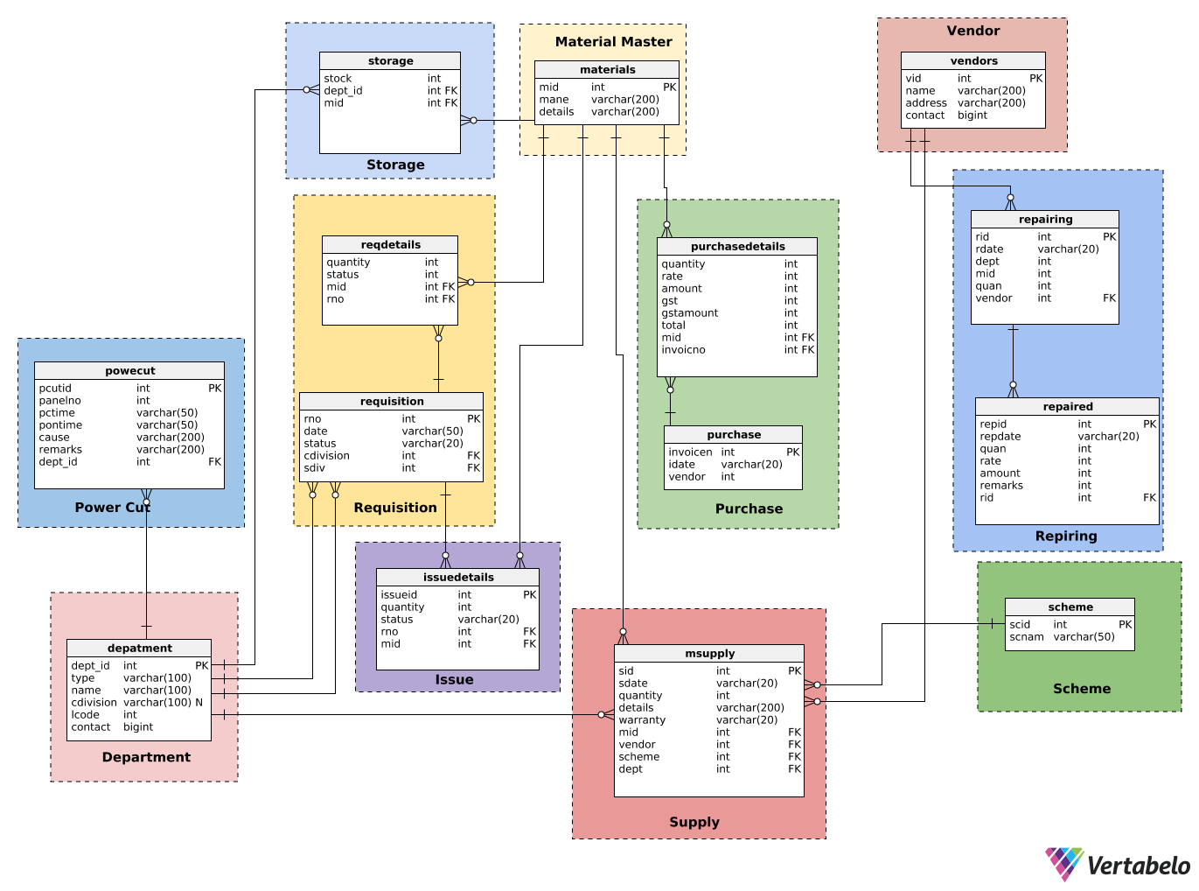

## 6.4 DATA DICTIONARY

**Table: Department**

|  |  |  |
| --- | --- | --- |
| **Field** | **Type** | **Key** |
| Dept_id | Int | Pri |
| Type | Varchar |  |
| Name | Varchar |  |
| Cdivision | Varchar |  |
| Lcode | Varchar |  |
| Contact | Bigint |  |

**Table: Materials**

|  |  |  |
| --- | --- | --- |
| **Field** | **Type** | **Key** |
| Mid | Int | Pri |
| Mname | Varchar |  |
| Details | Bigint |  |

**Table: Scheme**

|  |  |  |
| --- | --- | --- |
| **Field** | **Type** | **Key** |
| Scid | Int | Pri |
| sScname | Varchar |  |

**Table: Vendors**

|  |  |  |
| --- | --- | --- |
| **Field** | **Type** | **Key** |
| Vid | Int | Pri |
| Name | Varchar |  |
| Address | Varchar |  |
| Contact | Bigint |  |

**Table:Users**

|  |  |  |
| --- | --- | --- |
| **Field** | **Type** | **Key** |
| Userid | Int | Pri |
| Usertype | Varchar |  |
| Department | Varchar |  |
| Password | Varchar |  |

**Table:Users**

|  |  |  |
| --- | --- | --- |
| **Field** | **Type** | **Key** |
| Mid | Int | Pri |
| Dept_id | Int | Pri |
| Stock | Int |  |

**Table: Power-Cut**

|  |  |  |
| --- | --- | --- |
| **Field** | **Type** | **Key** |
| Pcutid | Int | Pri |
| Panelno | Int |  |
| Pctime | Varchar |  |
| Pontime | Varchar |  |
| Cause | Varchar |  |
| Remarks | Varchar |  |
| Dept_id | Int | FK |
| Date | Varchar |  |

**Table: Requisition**

|  |  |  |
| --- | --- | --- |
| **Field** | **Type** | **Key** |
| Rno | Int | Pri |
| Date | Varchar |  |
| Cdivision | Int | FK |
| Sdiv | Int | FK |
| Status | Varchar |  |

**Table: Requisition Details**

|  |  |  |
| --- | --- | --- |
| **Field** | **Type** | **Key** |
| Rno | Int | Pri |
| Mid | Int | Pri |
| Quantity | Int |  |
| Status | Varchar |  |

**Table: Issue Details**

|  |  |  |
| --- | --- | --- |
| **Field** | **Type** | **Key** |
| Issueid | Int | Pri |
| Rno | Int | FK |
| Mid | Int | FK |
| Quantity | Int |  |
| Status | Varchar |  |

**Table: Purchase**

|  |  |  |
| --- | --- | --- |
| **Field** | **Type** | **Key** |
| Invoiceno | Int | Pri |
| Idate | Varchar | FK |
| Vendror | Int |  |

**Table: Purchase Details**

|  |  |  |
| --- | --- | --- |
| **Field** | **Type** | **Key** |
| Invoiceno | Int | Pri |
| Mid | Int | FK |
| Quantity | Int |  |
| Rate | Int |  |
| Amount | Int |  |
| Gst | Int |  |
| Gst amount | Int |  |
| Total | Int |  |

**Table: Msupply**

|  |  |  |
| --- | --- | --- |
| **Field** | **Type** | **Key** |
| Sid | Int | Pri |
| Sdate | Varchar |  |
| Scheme | Int | FK |
| Mid | Int | Fk |
| Quantity | Int |  |
| Details | Varchar |  |
| Vendor | Int | FK |
| Warranty | Varchar |  |
| Dept | Int | FK |

**Table: Repairing**

|  |  |  |
| --- | --- | --- |
| **Field** | **Type** | **Key** |
| Rid | Int | Pri |
| Rdate | Varchar |  |
| Dept | Int | FK |
| Mid | Int | Fk |
| Quan | Int |  |
| Vendor | Int | FK |

**Table: Repaired**

|  |  |  |
| --- | --- | --- |
| **Field** | **Type** | **Key** |
| Repid | Int | Pri |
| Rid | Int | FK |
| Repdate | Varchar |  |
| Quan | Int |  |
| Rate | Int |  |
| Amount | Int |  |
| Remarks | Varchar |  |

# 7. CODING

## 7.1 Introduction

Once the design is completed, most of the major decisions about the system have been made. Now the design must be translated into a machine-readable form. The Code generation step performs this task. If the design performed in a detailed manner, code generation can be accomplished mechanistically.

The goal of coding or programming phase is to translate the design of the system produced in design phase into code in a given programming language, which can be executed by a Computer and that performs computations specified by the design. The Code generation should be designed in a manner to reduce input, control errors and accelerate the entire process.

Normally, good software development organizations adhere to some well-defined and standard style of Coding called Standards. Most software development organizations formulate their own coding standards that suit them most, the reasons for adhering to a standard coding style are as follows-

* It gives a uniform appearance to the codes written by different programmers.
* It enhances code understandability.
* It encourages good programming practices.

## 7.2 CODE EFFICIENCY

Code efficiency is one of the major tasks of the System Development Life Cycle (SDLC). It checks as to whether the access time is minimized or not, whether the errors are eliminated or not, whether the data integrity is maintained or not etc. To enhance the efficiency of the system, drop-down list are provided. Besides, drop down list box for item name entries are also provided. It is done so that the user would have the options to select the item name else they may enter incorrectly.

## 7.3 OPTIMIZATION OF CODE

Code optimization is one of the main tasks of the SDLC. It supplements the efficiency of the coding and is the penultimate stage of removal of any data redundancy and unnecessary occupation of the space.

In the proposed system, different types of the codes have been optimized such as looping codes.

Example: (for an unoptimizedcode)

If (condition 1> condition 2)

{

If (condition 1> condition 3)

Statement;

}

Now Example of optimized code-

If (condition 1> condition 2 && condition 1> condition 3)

{

Statement;

}

Besides, many checking features have been accommodated to stop the entry of unoptimized code. Necessary check constraints have been declared to stop unauthorized accessing retrieving of the data. If the user enters wrong data, the system has been designed to prompt the user, suggesting entering the correct data.

## 7.4 EVALUATION

Evaluation is to identify whether the system is serving the intended purpose of the organization and meeting the expected requirements of the user, its strength and weakness. For evaluation of the system, a list of satisfied users will be given to the organization concern, which is using the identical system for seeking their opinion.

# 8. SYSTEM TESTING

## 8.1 OVERVIEW

The quality of an information system depends on its design, development testing and implementation. One aspects of system testing is its reliability. A system is reliable if, used in a reasonable manner; it does not produce failures that are dangerous or over time costly.

An additional aspect of quality assurance is avoiding the need for enhancement on the one hand and developing software that is maintainable on the other. The need for maintenance is very high and impedes new developments. The greatest amount of maintenance is for user enhancement and improved documentation tasks that can be avoided or at least reduced in frequency through proper systems engineering. So, quality assurance is the review of software products and related documentation for completes correctness and maintainability. Besides these, it also includes assurance that the system meets the specifications and requirements for its intended use and performance.

## 8.2 TESTING

One of the most important level of quality assurance is system testing. Testing is the process of executing a program with the explicit intention of finding errors that is making the program fail. A successful testing is then finding the errors.

There are two strategies for testing software. These are

1. Code Testing

2. Specification Testing.

**Code Testing**

The code testing strategy examines the logic of the program. To follow this testing method the analyst develops the test cases resulting executing every instruction in the program or modules that is every path through the program is tested. A path is specific combination of conditions that is handled by the program.

**Specification Testing**

To perform specification testing, the analyst examines the specification stating what the program is going to do and how it should perform under various conditions. By examining the results, the analyst can determine whether the program performs according to its specified requirements.

## 8.3 LEVEL OF TESTING

Regardless of which strategy the analyst follows, there are preferred practices to ensure that the testing is useful. The levels of tests and types of data, combined with testing libraries are important aspects of the actual test process. Systems are not designed as entire systems nor are they tested as single systems. The analyst must perform.

**UNIT TESTING**

Unit testing is testing changes made in an existing or a new program. In the unit testing the analyst test the program making up a system. The software units in a system are the modules and routines that are assembled and integrated to perform a specific function. Unit testing focuses first on the modules, independently of one another, to locate errors. This enables the tester to detect errors in coding and logic that are contained within that module alone. Those resulting from the interaction between modules are initially avoided.

**SYSTEM TESTING**

No system design is perfect; several factors like communication gap between user and the system developer, or time constraints create error that must be eliminated before the system is ready for user acceptance and training. Goal achievement of a system can be recognized only after proper testing, rectification of error, if any. A small system error may conceivably explode into a much larger problem with the passage of time. Hence testing is vital to the success of a system.

System testing is executing a program to check logic changes made in it. With the intention of finding errors-making the program fails. Effective testing does not guarantee reliability. Reliability is a design consideration. The purpose of system testing is to identify and correct errors in the system.

System testing does not test software but rather the integration of the modules in the system and its original objectives, current specifications and system documentation. The primary concern is the compatibility of individual modules. The features to be tested and the plan varies from system to system, the first is to see whether it produces the correct output. Following test have been conducted in design and development of the current application system.

**OUTPUT TESTING**

The process is testing simultaneously both program (internal processes) and its output. Output produced by the system is compared with the desired output.

Each and every program is tested separately with synthetic data. Actually it is found to be identical. Corrections and modifications were required to be done in some programs.

**VOLUME TESTING**

Within this phase of various sizes were entered in the system and run to verify whether the new software function correctly or not. Since seven different data of records with different logic’s bulk or volume testing is most important acceptance.

**RECOVERY AND SYSTEM SECURITY TEST**

Without the facilities of backup recovery and security, the system is handicapped. Even in some instances it may cause several problems like loss of data. Forced system failures were introduced to test the security of stored data.

There are also facilities to take backup from hard disk to diskette and vice versa. Disk features of the system were tested.

**DOCUMENTATION TESTING**

An adequate number of components or messages are provided in each program in order to assist the user in taking awkward situation and for ease of using the system. The user was asked about the understandability and utility of these messages; the response from the user was taken in to consideration to make the system for novice user like them.

**ACCEPTENCE TESTING**

Acceptance testing is the last stage of system testing. Live data of the system having different details of information were entered and processed by the actual user of the system. They were sending to the concerned authority and found to be accepted. Then the authority recommended for implementation.

Synthetic data were composed by the system developers. During preparation of synthetic data it was in mind that the data should be exhaustive enough to revel all terms and conditions. Live data were taken from different paper files of the existing manual system of the host firm and inserted by real user.

# 9. DEBUGGING

Debugging occurs as a consequence of successful testing. When a test case uncovers an error, debugging is the process that results in the removal of the error. Although debugging can and should be an orderly process, it is still very much an art. A software engineer, evaluating the results of a test, is often confronted with a "symptomatic" indication of a software problem. That is, the external manifestation the error and the internal cause of the error may have no obvious relationship to one another. Debug process always begins with the execution of a test case. The results are assessed and a lack of correspondence between the expected and actual outcome is encountered. In many cases,  
the non-corresponding data are a symptom of an underlying cause that is as yet hidden. The debugging process attempts to match symptom with cause, thereby leading to error correction.

The debugging process will always have one of two outcomes:

* The cause will be found corrected and removed, or
* The cause will not be found. In the latter case, the person performing debugging may suspect a cause, design a test case to help validate his suspicion, and work toward error correction in an iterative fashion.

In general, three categories for debugging approaches may be proposed:

## 9.1 BRUTE FORCE

The brute force category of debugging is probably the most common and least  
efficient method for isolating the cause of a software error. This technique is applied when all else fails. Using a "let the computer find the error" philosophy, memory dumps are taken, run-time traces are invoked, and the program is loaded with WRITE/SYSTEM.OUT/PRINT statements. It is hoped that somewhere in the morass of information that is produced, we will find a clue that can lead us to the cause of an error. Although the mass of information produced may ultimately lead to success, it more frequently leads to wasted effort and time.

## 9.2 BACKTRACKING

This is a fairly common debugging approach that can be used successfully in small programs. Beginning at the site where a symptom has been uncovered, the source code is traced backward (manually) until the site of the cause is found. Unfortunately, as the number of source lines increases, the number of potential backward paths may become unmanageably large.

## 9.3 CAUSE ELIMINATION

The third approach to debugging - Cause Elimination is manifested by induction or deduction and introduces the concept of binary partitioning. Data related to the error occurrence are organized to isolate potential causes. A "cause hypothesis" is devised and the above data are used to prove or disprove the hypothesis. Alternatively, a list of all possible causes is developed and tests are conducted to eliminate each. If initial tests indicate that a particular cause hypothesis shows promise, the data are refined in an attempt to isolate the bug. Each of the above-mentioned debugging approaches can be supplemented with debugging tools. In all the modules developed, a combination of brute force & causeelimination debugging methodology was used. The unit-testing portion used the former approach wherein either input statement was given to find the error or some piece of code was inserted to trace some values. Functional testing was done using the latter approach. Out of all the debugging exercises, the team members took up debugging at the functional testing stage jointly.

# 10. SYSTEM IMPLEMENTATION AND MAINTENANCE

## 10.1 IMPLEMENTATION

A crucial phase in the system development life cycle is successful implementation of new system design. Implementations simply mean converting new system design into operation. This is the moment of truth the first question that strikes in every one’s mind that whether the system will be able to give all the desired results as expected from system. System testing checks the readiness and accuracy of the system to access update  
and retrieve data from the new files. Once the program becomes available, test data are read into the computer and processed against the files provided for testing. If successful, the program is the run with live data. Otherwise, a diagnostic procedure is used to locate and correct the errors in program.

There are three main types of implementation-

* Implementation of a computer system to replace the manual system.
* Implementation of a new computer system to replace an existing one.
* Implementation of a modified application to replace an existing one.

The term implementation has different meanings, ranging from the conversion of abasic application to a complete replacement of computer system. Implementation is used here to mean the process of converting a new or revised system design into an operational one. Conversion is one aspect of implementation. Since the system is web-based system, there is not much procedure involved in implementing the system. After completion of the development of this system and after a through testing of the different aspect of the system, this system will be ready for implementation. The other aspects of system implementation are the post implementation review and software maintenance.

## 10.2 POST IMPLEMENTATION REVIEW

After the system is implemented and system conversion is completed, a review of the system is usually conducted by the user and the analyst to determine whether the system is meeting its desired expectations. It should be a formal process to determine how well the system is working, and how it has been expected.

## 10.3 MAINTENANCE

Software maintenance traditionally denotes the process of modifying a software product after it has been delivered to the customer. Maintenance is inevitable for almost any kind of product.

Most of the software products need maintenance on account of the  
following three main reasons:

*  **Corrective:** Corrective maintenance of a software product may be necessary either to rectify some bugs observed while the system is in use, or to enhance the performance of the system.
* **Adaptive:** A software Product might need maintenance when the customer need the product to run on new platforms, on new operating systems, or when they need the product to interface with new hardware or software.
*  **Perfective**: A software product needs maintenance to support the new feature that the users want or to change different functionalities of the system according to customer demands.

Software maintenance is an important activity of every organization as the rate of hardware obsolescence is very high. Also the demand of user community to see the existing software product run on newer platforms, run in newer environment with enhanced features.

# 11. SECURITY

Every system must provide built in features for security and integrity of data. Without safeguard against unauthorized access, fraud, embezzlement, fire and natural disaster, a system could be so vulnerable as to threaten the survival of the organization. The end user is always concerned about security along with increased dependence on the computer. In the system development, the developer and the system analyst must consider measures for maintaining data integrity and controlling security at all times.

* **Physical Security:** The most costly loss in software is program error. It is possible to eliminate such error through proper testing routines. Parallel runs should be implemented whenever possible. Physical security provides safeguards against the destruction of hardware, databases and documentation; fire, flood, theft, sabotage and cave dropping; and loss of power through proper backup.
* **Database Security:** The proper use of the file library is another important security features. This involves adequate file backup and reliable personal to handle file documentation when needed. File backup means keeping duplicates copies of the master and the other key files and storing them in suitable environmental conditions.
  + - The database security of the proposed system is done very well. The proposed system’s database is in the MySQL environment. It can be dumped easily whenever needed from MySQL consol.
* **Application Security:** The complexity of the system makes auditing necessary. Neither the auditor nor the user can verify the system check itself. The internal controls required means that the programmer and analyst build controls into every system. Developing a corporate auditing policy will ensure that future system meet the minimum requirements for security and control against fraud and embezzlement.
* **Transaction Entry:** A logical failure occurs when activity to the database is interrupted with no chance of completing the currently executing transactions. When the system is and running again it is not known whether or not modification is still in memory or was made to the actual data. Through still readable, the database may be inaccurate.

# 12. SCREENSHOTS

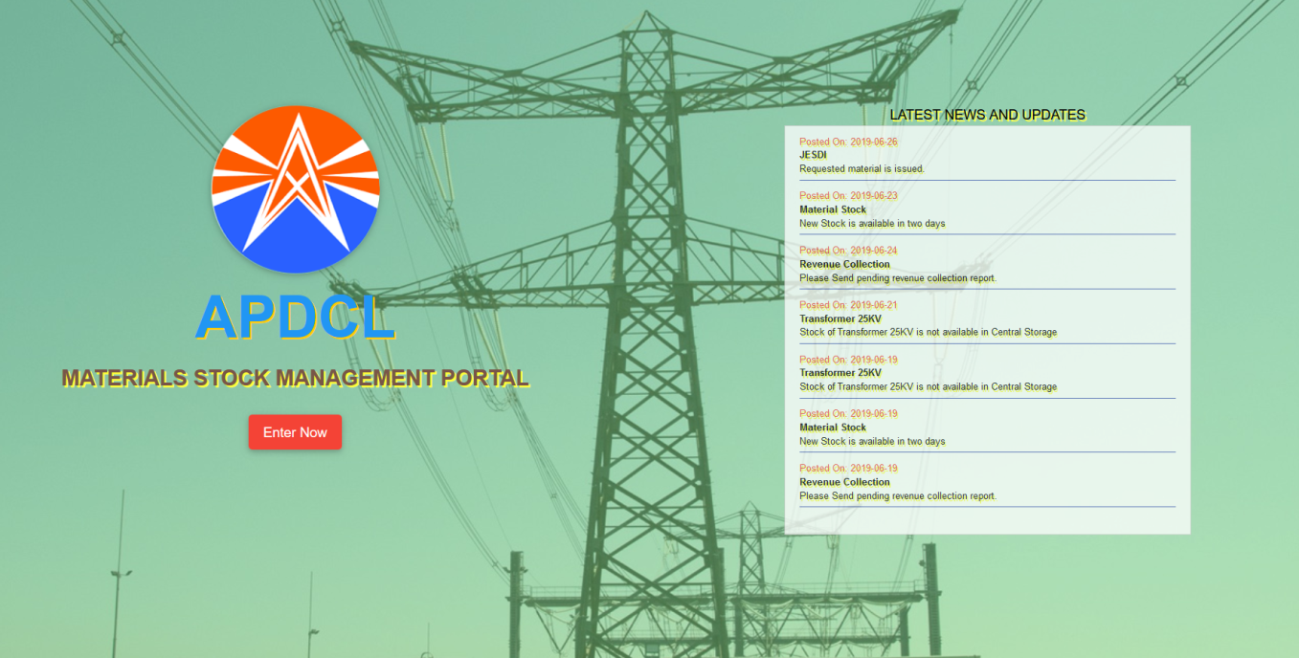

**Index Page**

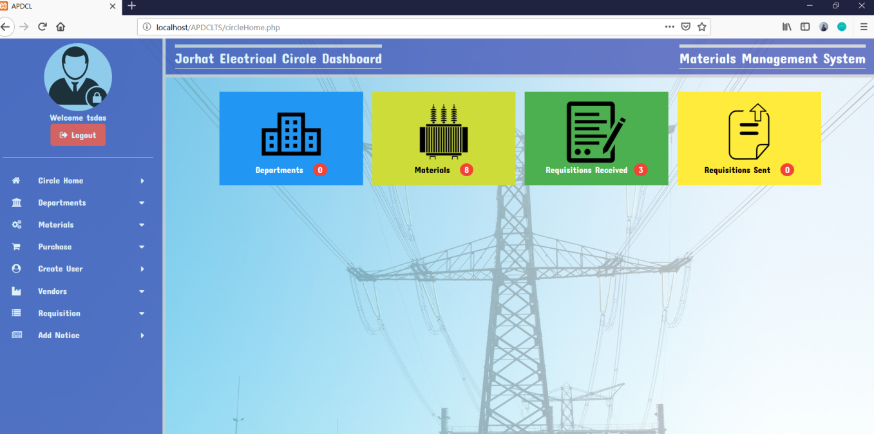

**Circle Dashboard**

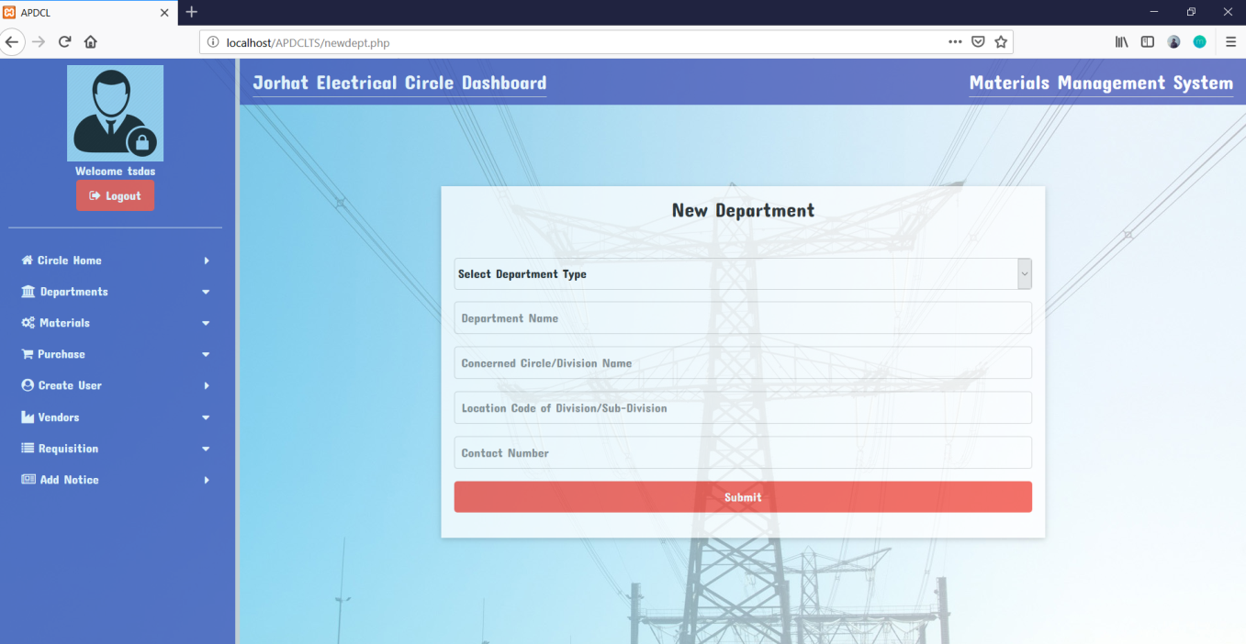

**Add Department Form**

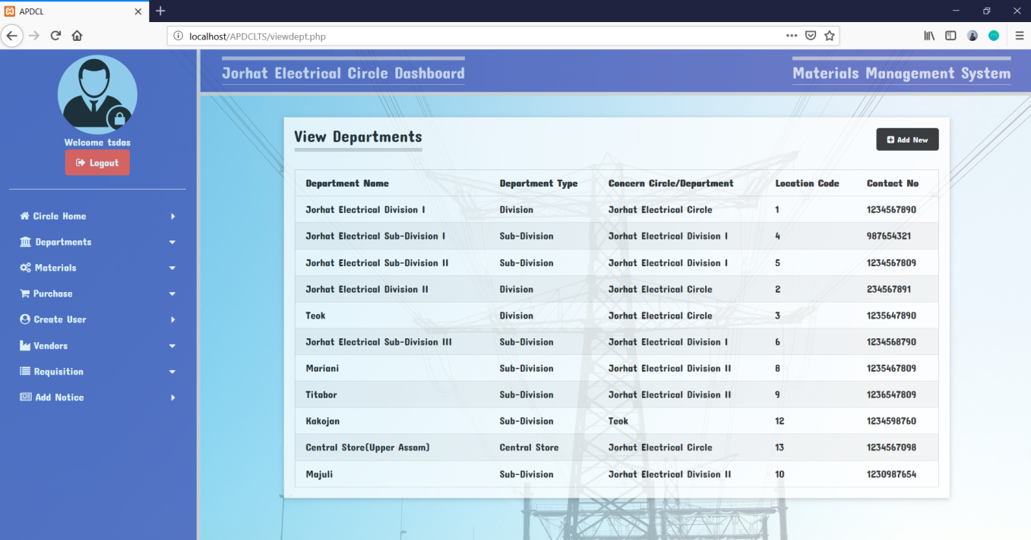

**View Department Details**

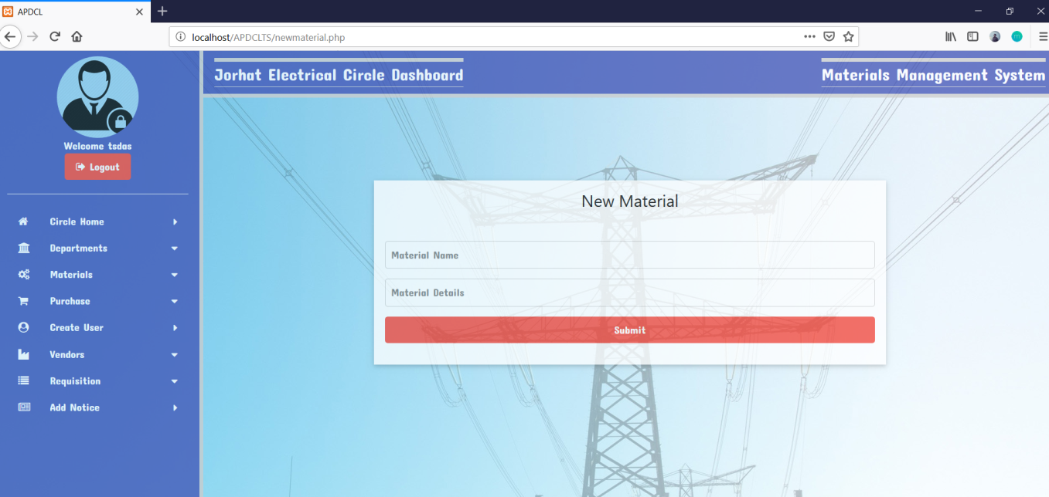

**Add Material Form**

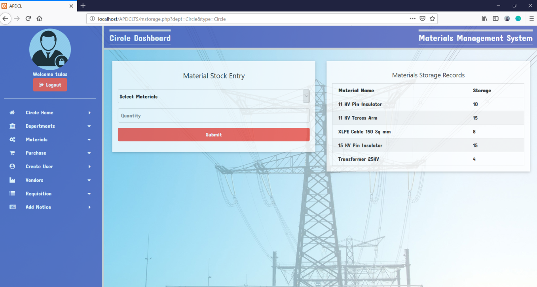

**Add & View Stock of Material**

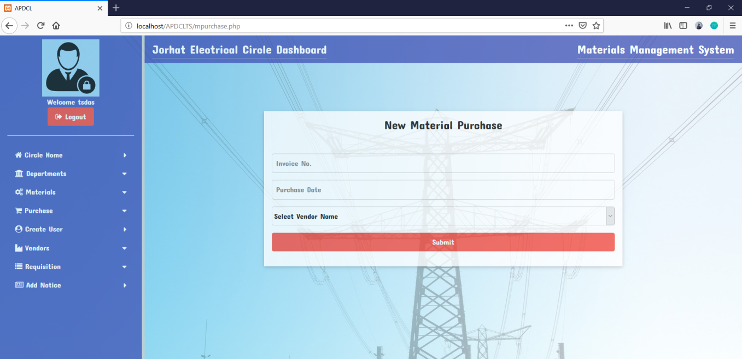

**Add Purchase Form**

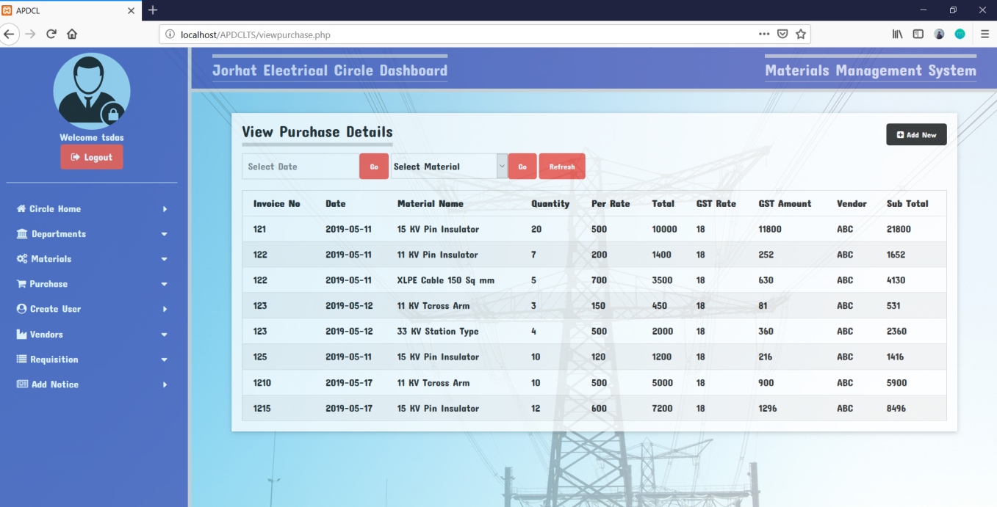

**View Purchase Details**

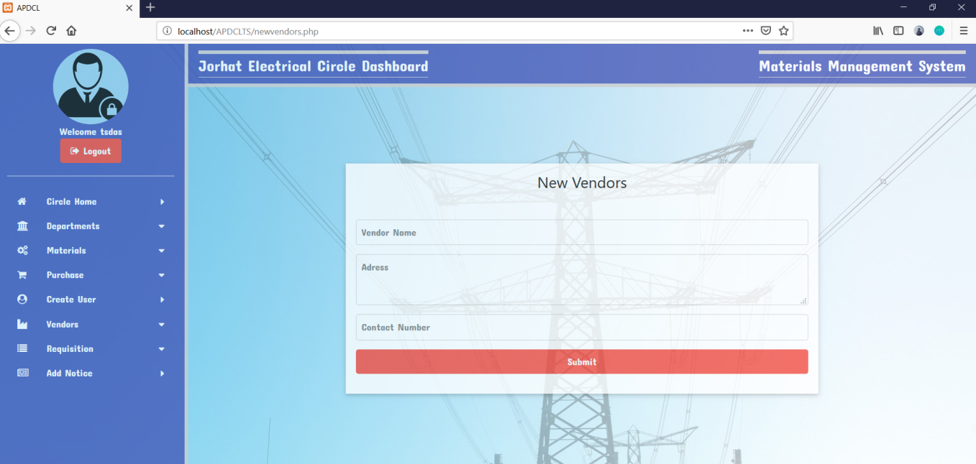

**Add Vendor Form**

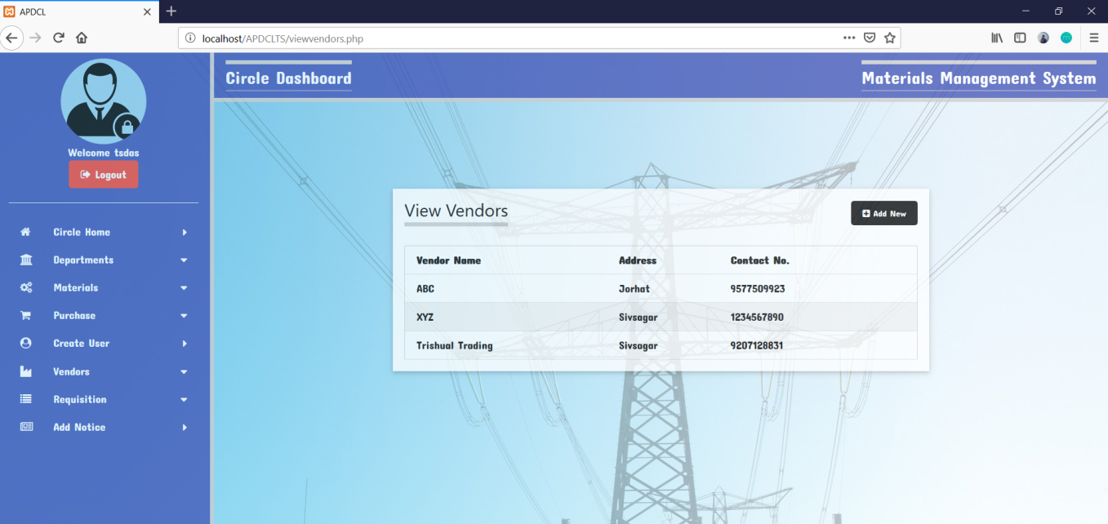

**View Vendor Details**

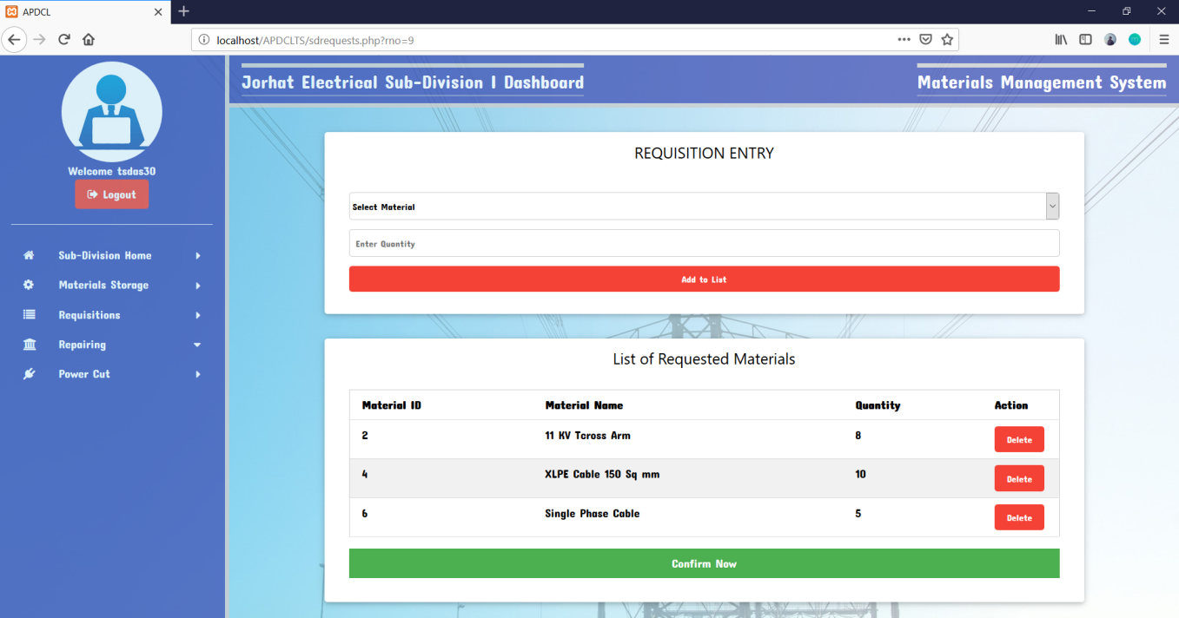

**Sent Requisition Form**

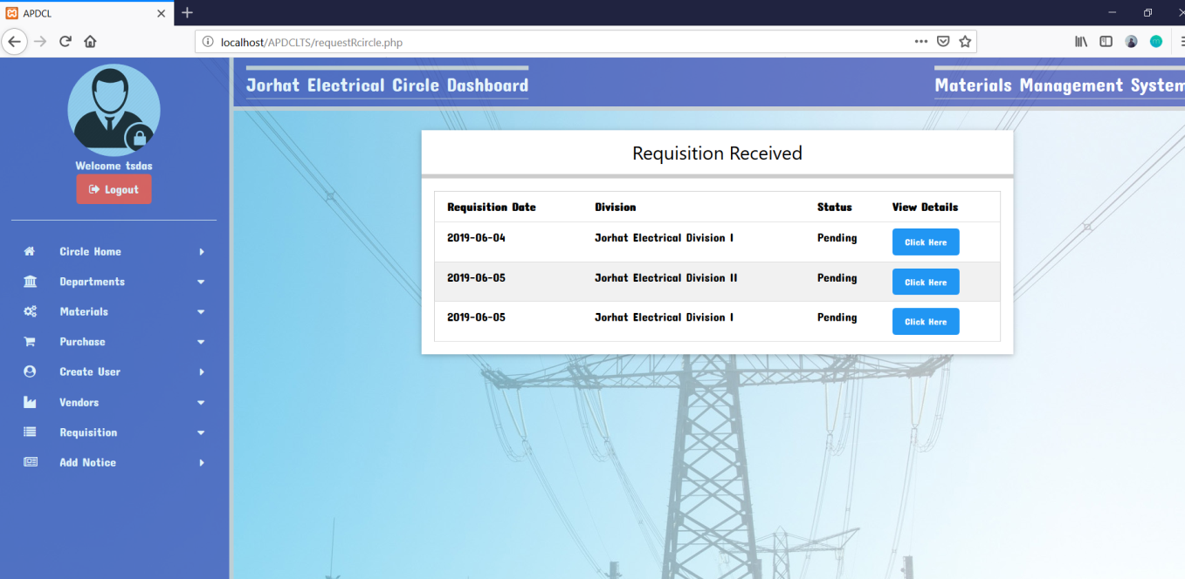

**Requisition Received**

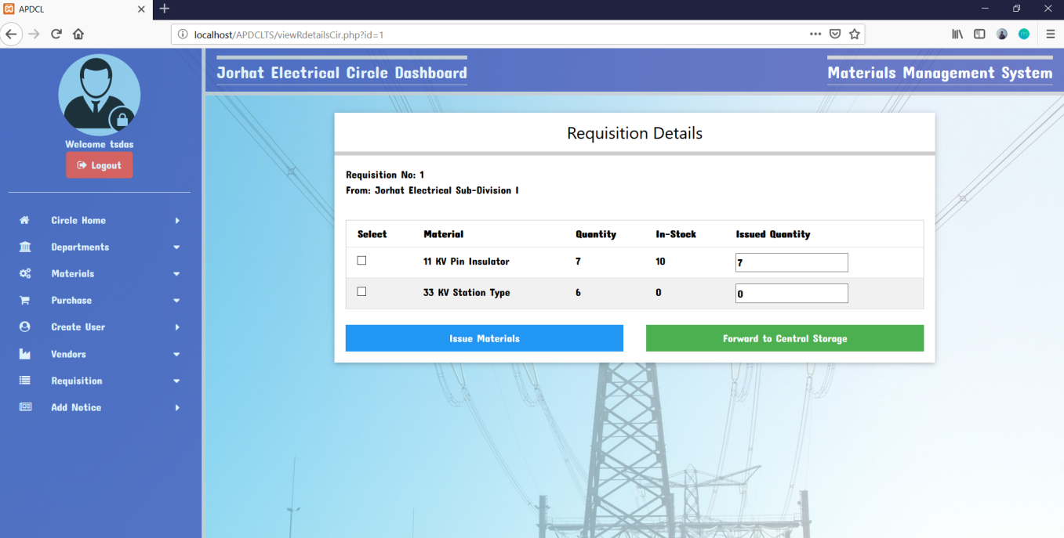

**View Requisition Details**

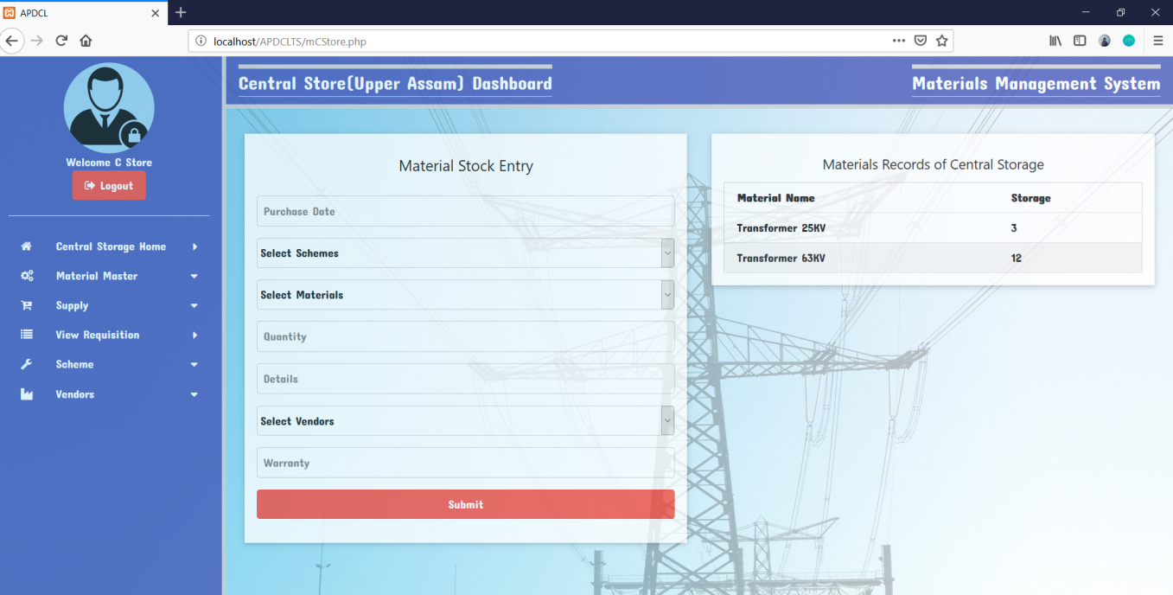

**Add Supply & View Stock**

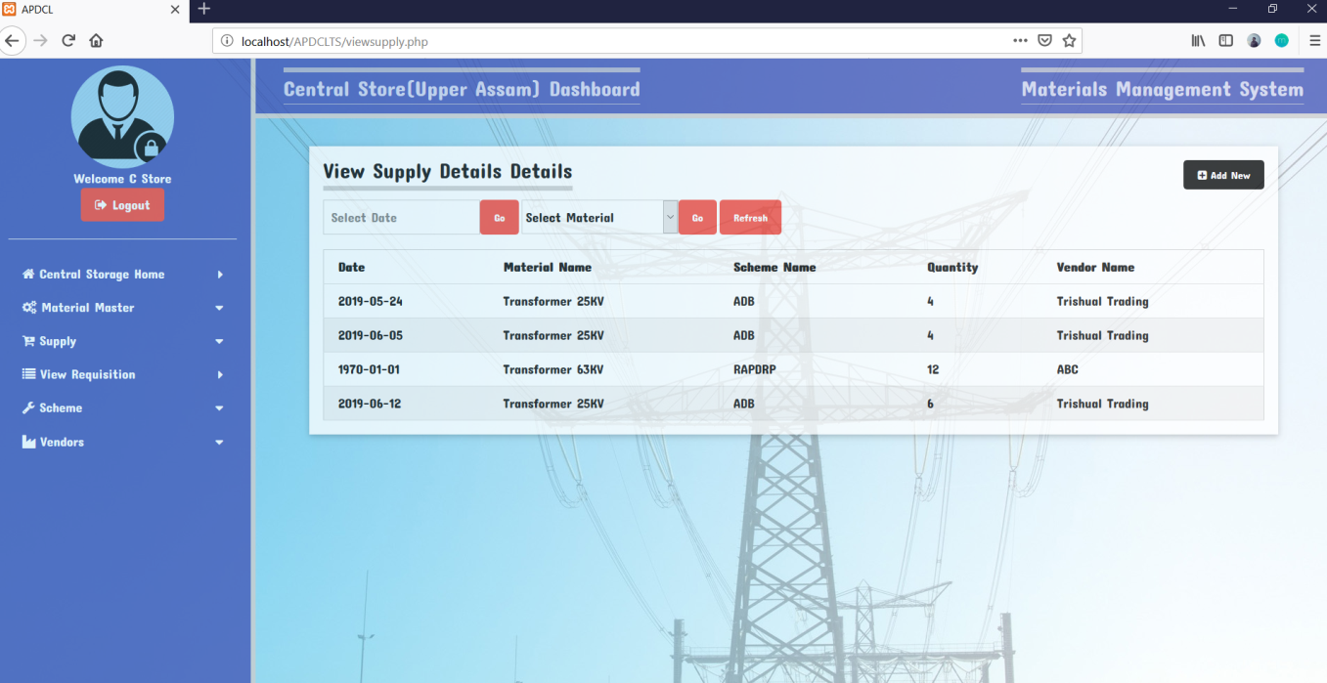

**View Supply Details**

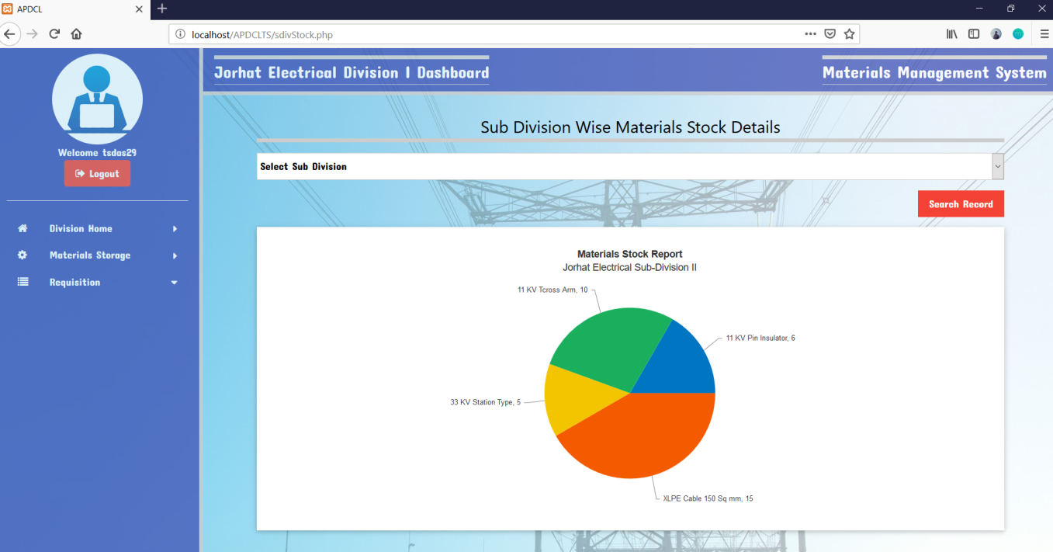

**Sub-Division Wise Materials Stock Details**

**ii**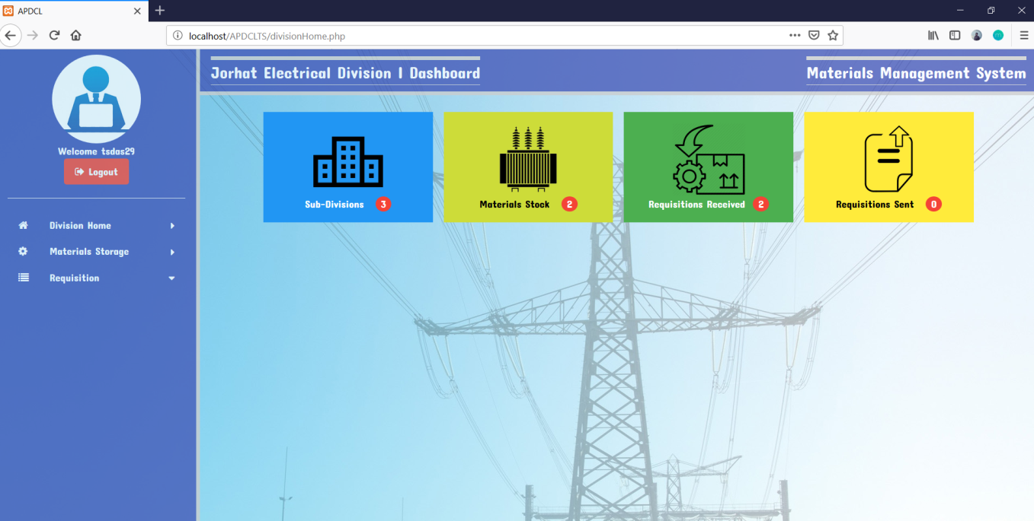

**Division Dashboard**

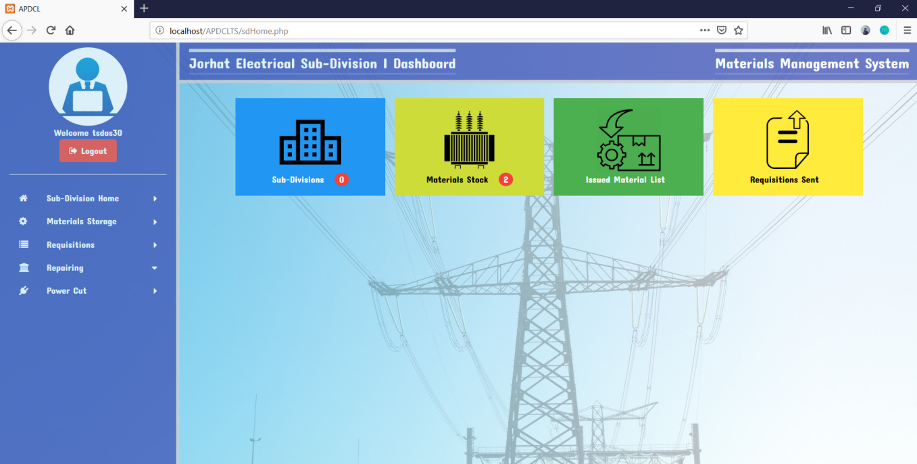

**Sub-Division Dashboard**

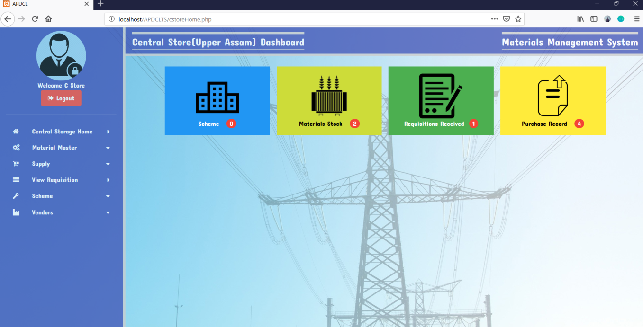

**Central Store Dashboard**

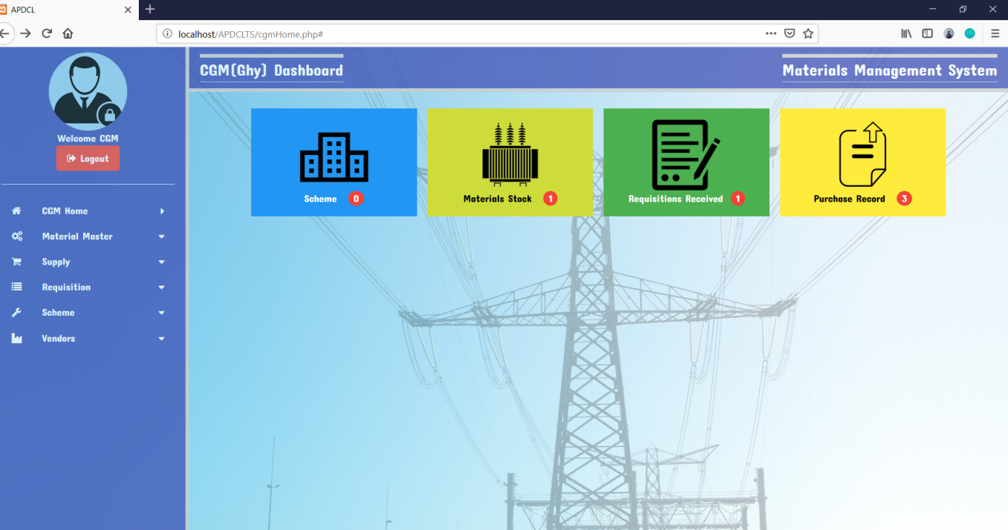

**CGM Dashboard**

# 13. CONCLUSION

The project **“Material Stock Management System For Jorhat Electrical Circle”** is fully integrated web-based software developed to provide a easy way to store and requisitioned various materials for different divisions and sub-divisions of the **Jorhat Electrical Circle**.

The proposed system was developed by following the requirements given by **Jorhat Electrical Circle**. Coding was done as per the standards and general coding guidelines were decided so as to have a consistent coding standard across different parts of the proposed system.

The project is still in its growth phase and will be implemented soon as this system is under development, still we are putting our best effort and knowledge to make the system as much error free as possible. Thus the main objective of developing a system that is reliable, efficient and meet all the requirements was carried out.

It can be concluded that developing the System was a real learning experience. The principles of software production were well implemented throughout the system. The project has been as per as the given specification and has been made as user friendly as possible.

As there is always a scope of further development in any software product, and the same is true for this project as well. The end-user will decide its scope in future applications. This will help in developing a better system which will serve them in a better way. This project is flexible enough to incorporate any requirement changes.

# 14. BIBLIOGRAPHY

## Books Referred:

1. Fundamentals of Software Engineering - byRajib Mall
2. PHP MYSQL Vijaymukhi
3. Professional PHP(Wrox Publication)

## Websites referred:

1. [www.google.com](http://www.google.com)
2. [www.w3schools.com](http://www.w3schools.com)
3. [www.stackoverflow.com](http://www.stackoverflow.com)
4. [http://en.wikipedia.org](http://en.wikipedia.org/)
5. [www.tutorialspoint.com](http://www.tutorialspoint.com)